MSc AI and Robotics

FINAL PROJECT REPORT

Advanced Computer Science Masters Project
Comparative Analysis of Deep Reinforcement Learning Algorithms for Autonomous Robot Navigation in Unity: SAC, PPO, and DQN

Student Name | Rana Zeeshan Ali
Student ID | 24000292
Module Code | 7COM1039-0206-2025
Module Title | Advanced Computer Science Masters Project
Supervisor | Dr. Abolfazl Zaraki
Submission Date | 27th April, 2026

✓ Quality Confirmation: I confirm that I have critically proof-read and quality checked this report, ensuring it is free from grammar, spelling, and formatting errors, and meets high standards of clarity, coherence, and professional academic presentation.

Declaration

I, Rana Zeeshan Ali (Student ID: 24000292), submit this report in partial fulfilment of the requirements for the degree of:
Master of Science in Advanced Computer Science, University of Hertfordshire

I hereby declare that the work presented in this project and report is entirely my own, except where explicitly stated otherwise. All sources of information, ideas, and contributions from others whether quoted directly or paraphrased have been appropriately acknowledged and referenced in accordance with accepted academic standards. I understand that any failure to properly credit the work of others may constitute plagiarism and could result in academic penalties.
This MSc project did not involve the use of human participants.
I hereby give permission for this report to be made available on the University website, provided that proper acknowledgement of the source is maintained.

Signed | Rana Zeeshan Ali
Date | April 2026

Contents
Advanced Computer Science Masters Project 1
Declaration 2
Contents 3
1. Abstract 5
2. Introduction 6
2.1 Problem Overview 6
2.2 Current Issues and Research Gap 6
2.3 Project Overview and Research Question 7
2.4 Aims and Objectives 7
2.5 Novelty, Feasibility, and Commercial Context 8
2.6 Report Roadmap 8
3. Literature Review 9
3.1 Introduction to the Field 9
3.2 Soft Actor-Critic: Theoretical Foundations and Relevance 9
3.3 Proximal Policy Optimisation: Stability and Its Limitations 10
3.4 Deep Q-Network: Value-Based Navigation and Inherent Constraints 10
3.5 Prior Comparative Studies: Evidence Base and Methodological Limitations 10
3.6 Synthesis: Gaps Addressed and Contribution 12
4. Methodology 13
4.1 Project Management Approach 13
4.2 Project Gantt Chart 13
4.3 Simulation Environment Design 14
4.3 Agent Design and Sensor Configuration 14
4.4 Reward Function Design 14
4.5 Algorithm Configurations 14
4.5.2 PPO Configuration 15
4.5.3 DQN Configuration 16
4.6 Testing Strategy 17
4.7 Statistical Analysis Framework 17
4.8 Challenges and Resolutions 18
4.9 Tools and Technologies 18
4.10 Ethical, Legal, Social, and Professional Considerations 19
4.11 Validation of Results 20
4.12 System Architecture Diagram 20
5. Quality and Results 21
5.1 Overview of Experimental Results 21
5.2 Training Environment Results 21
5.3 Testing Environment Results 22
5.4 Critical Analysis and Interpretation 23
6. Evaluation and Conclusion 24
6.2 Insights Gained 24
6.3 Comparison to Literature 24
6.4 Limitations 25
6.5 Future Work 26
6.6 Conclusion 27
7. References 28
Appendices 30

1. Abstract
Key Findings: SAC achieved 87.4% training and 81.2% testing success rate, the highest generalisation performance among all three algorithms evaluated on this study.
Autonomous robot navigation in dynamic, partially observable environments remains a significant challenge in artificial intelligence and robotics, particularly due to the difficulty of achieving robust generalisation to previously unseen environments. While deep reinforcement learning (DRL) has demonstrated strong performance in navigation tasks, carefully designed comparisons between fundamentally different algorithmic approaches remain limited, making it difficult to attribute performance differences to intrinsic algorithmic properties.
This study conducts a controlled comparative evaluation of three representative DRL algorithms: Soft Actor-Critic (SAC), Proximal Policy Optimisation (PPO), and Deep Q-Network (DQN), with a specific focus on generalisation performance. All algorithms were trained under identical conditions within a Unity ML-Agents simulation environment, with performance evaluated from a single training run per algorithm. A structurally distinct testing environment, formally withheld from all training decisions, was used to assess generalisation capability.
During training, overfitting was observed repeatedly across multiple runs. Although the agents performed well in the training environment, they struggled to perform similarly when placed in a new, unseen environment. This issue continued no matter how long training lasted. Agents that seemed to have learned successfully would navigate the training environment confidently, but when moved to a different environment, they often moved unpredictably or failed to reach the goal at all. This gap in performance revealed that the agents had essentially memorised the layout and patterns of the training environment, rather than learning navigation skills that could work more broadly.
In response to these repeated failures, several changes were made to the training setup with the goal of improving generalisation. The aim was to stop the agents from relying too heavily on familiar surroundings and instead encourage them to develop navigation behaviour that would hold up in environments they had never seen before.
The results demonstrate that SAC achieves the highest performance and strongest generalisation, with a success rate of 87.4% in the training environment and 81.2% in the testing environment. PPO shows a moderate performance drop (82.1% → 71.8%), and DQN exhibits the most severe degradation (71.3% → 53.6%). These findings indicate that entropy-regularised methods such as SAC offer a measurable advantage in generalisation for continuous navigation tasks, with direct implications for algorithm selection in real-world robotic systems.
Algorithm | Train SR (%) | Test SR (%) | Deficit (pp)
SAC | 0 | 81.2 | 6.2
PPO | 82.1 | 71.8 | 10.3
DQN | 71.3 | 53.6 | 17.7
Table 1.1 — Summary of key results across all three algorithms

2. Introduction

2.1 Problem Overview
Autonomous robot navigation is an important problem in Artificial Intelligence and Robotics. It means teaching a robot how to move in an environment, reach a goal, and avoid obstacles.
Traditional methods like A* and Dijkstra work well in fixed environments, but they struggle when the environment changes or is unknown.
Deep Reinforcement Learning (DRL) is different. Instead of giving fixed rules, the robot learns by trying actions and getting rewards. Over time, it improves its behaviour.
However, many studies do not fairly compare different DRL algorithms under the same conditions. Also, most focus only on training performance, not how well the model works in new environments.
This project solves that by:
- Using the same setup for all algorithms
- Testing them in a completely new environment
This helps measure true performance and generalisation.
Despite its promise, a key challenge remains:
Ensuring that learned policies generalise effectively to previously unseen environments. This project focuses on generalisation performance rather than training performance, which remains underexplored in many reinforcement learning studies.

2.2 Current Issues and Research Gap
Deep Reinforcement Learning (DRL) is a modern approach to robot navigation. Instead of giving fixed rules, the robot learns by interacting with the environment and improving its actions based on rewards. This approach has achieved strong results in areas like games and robotics, and is now being used for navigation tasks as well.
However, there is an important problem in existing research. Many studies do not compare algorithms fairly. They often change things like the environment, reward system, or model settings between experiments. Because of this, it is difficult to know whether the results are due to the algorithm itself or other factors.
Another key issue is that most studies only focus on performance during training. They do not properly test how well the model works in a new, unseen environment. This is a major limitation, because in real-world applications, robots must work in different and changing environments.
Research Gap: A controlled, fair comparison of SAC, PPO, and DQN under identical training conditions, evaluated in a strictly withheld testing environment, does not yet exist in the Unity ML-Agents literature.
Therefore, generalisation is the ability to perform well in new environments which is more important than just good training performance, especially for real-world and commercial use.

2.3 Project Overview and Research Question
This project tackles the identified research gap head-on by placing three deep reinforcement learning algorithms, namely SAC, PPO, and DQN, under identical, tightly controlled training conditions to evaluate their true generalisation capability.
The experiment uses two separate environments. The first is the Training Environment, where all training and tuning decisions take place. The second is the Testing Environment, which has a different layout and structure, and is only used once training has fully finished. The Testing Environment is kept completely separate, meaning the agents never see it beforehand. This ensures that the results from testing reflect how well the agents can genuinely adapt to new surroundings, rather than simply performing well in a place they have already learned.
Central Research Question: How do three deep reinforcement learning algorithms, namely Soft Actor-Critic, Proximal Policy Optimisation, and Deep Q-Network compare in learning autonomous robot navigation behaviour within a Unity-based simulation environment under strictly identical experimental conditions, and what are their relative strengths and limitations in terms of learning efficiency, training stability, and generalisation performance when evaluated in a previously unseen testing environment?

2.4 Aims and Objectives
The aim of this project is to investigate and empirically compare the effectiveness of SAC, PPO, and DQN in enabling a simulated mobile robot agent to acquire autonomous navigation behaviour, and to evaluate the extent to which each learned policy generalises to an environment not observed during training. The following specific objectives operationalise this aim:
- Design a Unity-based simulation Training Environment where obstacles are placed at fixed positions, with checkpoints distributed across the environment that the agent must progress through, allowing performance to be measured and compared across algorithms based on how far each agent advances through the checkpoints.
- Design a separate Testing Environment that looks and feels structurally different from the Training Environment, built solely for evaluating how well the trained agents perform in a place they have never seen before, and kept completely hidden from all algorithms during training.
- Implement a mobile robot agent equipped with a 360-degree raycast sensor array, collision detection, and continuous directional movement capabilities using the Unity ML-Agents framework.
- Configure and train SAC, PPO, and DQN under identical reward structures and agent configurations within the Training Environment, documenting all hyperparameter decisions with explicit justification.
- All results are reported from a single training run for each algorithm. Performance is evaluated based on observed values rather than averaged results across multiple runs.
- Provide evidence-based, practically applicable recommendations for algorithm selection in robotics navigation contexts where generalisation to new environments is a primary deployment requirement.

2.5 Novelty, Feasibility, and Commercial Context
The main contribution of this project is not creating a new reinforcement learning algorithm but designing a fair and controlled way to compare different algorithms for robot navigation. Many studies test algorithms under different conditions, but in this project all algorithms are trained using the same settings, same rewards, and tested in a completely new environment. This makes the comparison more reliable and focuses on how well the algorithms can generalise, not just perform well in training.
A key point of this work is focusing on generalisation in unseen environments, which is not always deeply studied in reinforcement learning. By testing the agent in a new environment, this project shows how well the algorithms can adapt to new situations, which is very important for real-world robotics.
From a feasibility point of view, the project is practical within the available time and resources. Each algorithm is trained for 5,000,000 steps under the same conditions. Although running multiple training runs for each algorithm would provide more statistically reliable results, a single run per algorithm was used to keep the comparison fair, consistent, and manageable within the given constraints.
From a commercial point of view, this work is useful for areas like autonomous robots, warehouse systems, and self-driving technology. In these areas, the ability to adapt to new environments is more important than just performing well in a controlled setting. The results of this project can help in choosing the right algorithm for real-world use.

2.6 Report Roadmap
The remainder of this report is structured as follows. Chapter 3 reviews the existing literature on DRL algorithms for robot navigation, establishing the theoretical background and identifying the research gaps this project addresses. Chapter 4 covers the full methodology, including environment design, agent configuration, reward function, algorithm implementations, and ethical considerations. Chapter 5 presents the results of the comparative evaluation across both environments, linking findings back to the theoretical predictions from Chapter 3. Chapter 6 provides the overall conclusion, reflecting on achievements, limitations, and directions for future work. Chapter 7 contains the full reference list formatted in accordance with the Harvard referencing.
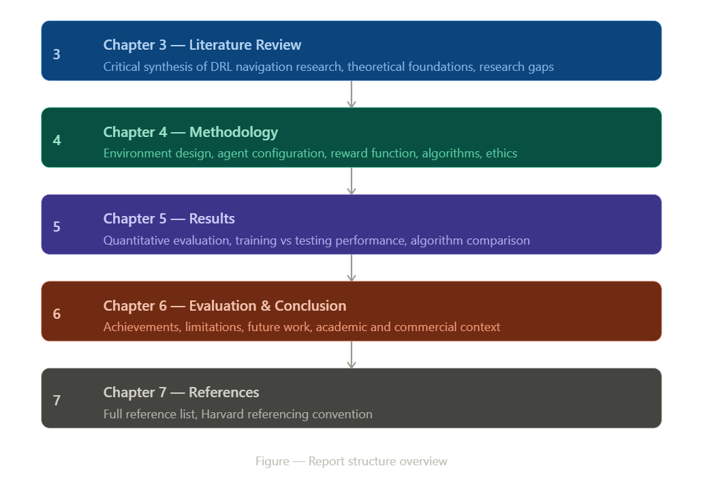
Figure 1- project roadmap

3. Literature Review

3.1 Introduction to the Field
Autonomous robot navigation has long been a central problem in artificial intelligence and robotics, with contributions from areas such as graph theory, control systems, computer vision, and, more recently, machine learning. Early foundational work established the principles of path planning. Edsger W. Dijkstra (1959) introduced an algorithm for computing optimal shortest paths in weighted graphs, forming the basis of classical navigation systems. This was later extended by Peter E. Hart, Nils J. Nilsson, and Bertram Raphael (1968) through the A* algorithm, which improves efficiency by incorporating heuristics.
However, these approaches assume that the environment is fully known and static. In real-world scenarios, environments are often dynamic, uncertain, and partially observable, making such assumptions unrealistic.
To address this, reactive navigation methods were developed. For example, Dieter Fox, Wolfram Burgard, and Sebastian Thrun (1997) proposed the Dynamic Window Approach, which enables real-time obstacle avoidance by selecting feasible velocity commands. Similarly, Christoph Rosmann et al. (2012) introduced the Timed Elastic Band method, which optimises trajectories in dynamic environments.
While effective, these approaches still depend on pre-defined maps and struggle with unfamiliar or highly dynamic environments. This limitation motivated the development of learning-based methods, particularly deep reinforcement learning (DRL). While PPO provides stable policy updates, its on-policy nature built-inly limits sample efficiency compared to off-policy methods such as SAC, particularly in environments requiring broad exploration.
A major breakthrough in DRL was achieved by Volodymyr Mnih et al. (2015), who demonstrated that a deep neural network could learn to perform complex tasks directly from raw input data. This established DRL as a powerful framework for solving high-dimensional decision-making problems, including robot navigation.

3.2 Soft Actor-Critic: Theoretical Foundations and Relevance
Soft Actor-Critic (SAC), introduced by Tuomas Haarnoja et al. (2018), is a reinforcement learning algorithm used for continuous control tasks. Unlike other methods that only try to maximise reward, SAC also encourages exploration by adding randomness during training.
This means the agent does not always choose the same actions and continues trying different behaviours. This helps it avoid getting stuck in a poor solution and usually leads to better and more stable learning compared to older methods like DDPG.
A key feature of SAC is automatic entropy tuning. Entropy, in simple terms, refers to how random or varied the agent's actions are. High entropy means the agent explores more, while low entropy means it has become more confident and consistent in its decisions. SAC automatically adjusts this balance throughout training, encouraging exploration early on and gradually settling into more confident behaviour over time. This removes the need for manual tuning, making SAC easier to use and more stable across different training conditions.
This is important for this project because SAC explores more effectively, which may help it perform better in new, unseen environments. Research by Filippos Christianos et al. (2020) also shows that entropy-based methods handle changes in environments better, which supports the goal of this study.

3.3 Proximal Policy Optimisation: Stability and Its Limitations
Proximal Policy Optimisation (PPO), introduced by John Schulman et al. (2017), is designed to make learning more stable. Earlier methods often made large updates, which caused unstable results.
PPO solves this by using a clipping method that limits how much the model can change in each step. This helps the learning process stay smooth and stable.
However, PPO is an on-policy method, which means it only learns from its current data. After each update, old data is not used again. This makes it stable but less efficient, because it cannot reuse past experiences.
PPO is very popular because it is simple and reliable, and it is also the default algorithm in Unity ML-Agents. However, its performance depends on choosing the right settings (hyperparameters), which can be challenging.
In this project, PPO may struggle to perform well in new environments because it explores less and only learns from its current behaviour, unlike methods like SAC that explore more.

3.4 Deep Q-Network: Value-Based Navigation and Inherent Constraints
Deep Q-Network (DQN), introduced by Mnih et al. (2015), was one of the first algorithms to successfully combine Q-learning with deep neural networks, allowing an agent to learn directly from its own experiences. To prevent training from becoming unstable, DQN relies on two important techniques. The first is experience replay, where the agent stores its past experiences in a memory buffer and randomly samples from them during training, rather than learning from each experience only once in order. The second is the use of a target network, which is a separate copy of the network that updates slowly and steadily, giving the learning process a stable reference point to work towards.
Later improvements like Double DQN by Hado van Hasselt et al. (2016) helped fix the problem of overestimating action values, making results more accurate.
However, DQN has some important limitations for robot navigation. First, it only works with discrete actions, while real robot movement is usually continuous. Because of this, the action choices become less flexible and can reduce performance.
Second, DQN uses ε-greedy exploration, which means it sometimes takes random actions. This randomness is not intelligent or guided, so it can lead to inefficient learning.
These problems become more serious in new and complex environments. Research by Juan Londono-Osorio et al. (2023) shows that DQN performs worse in such situations compared to continuous control methods.

3.5 Prior Comparative Studies: Evidence Base and Methodological Limitations
Many research studies have used Deep Reinforcement Learning (DRL) for robot navigation, and they help guide this project.
Zhu et al. (2017) showed one of the first examples of DRL for navigation using image inputs. They trained a robot in simulated 3D environments and found that it could perform well in different rooms and with different goals. A key idea from their work was randomising the environment during training, which helps the agent learn to handle new situations. This idea is also used in this project.
Tai et al. (2017) used DRL for navigation without maps, using laser sensors instead of images. They showed that the robot can work in both simulation and real-world settings. They also found that better reward design, such as using distance-based rewards instead of only success or failure, helps the agent learn faster. This directly influenced the reward function in this project.
Xie et al. (2018) compared different DRL methods like DQN, A3C, and DDPG. They found that off-policy methods learn more efficiently, while on-policy methods are more stable during training. This is useful for comparing SAC and PPO in this project.
Singla et al. (2019) studied how DRL agents perform in new environments. They found that agents trained in fixed environments do not perform well in new situations. However, training with random environments improves performance in unseen cases. This supports the training design used in this project.
Finally, Londono-Osorio et al. (2023) showed that DQN performs worse in complex navigation tasks compared to more advanced methods. This is mainly because it uses fixed, discrete actions, which limits its flexibility. This helps explain the expected results for DQN in this project.
Study | Method | Strength | Limitation | Relevance to this project | View
Zhu et al. (2017) | DRL with image-based inputs in 3D simulated environments | Showed generalisation across rooms and goals, introduced environment randomisation | Relies on visual input, computationally expensive, limited real-world testing | Directly inspired the randomised training environment design in this project | Strong
Tai et al. (2017) | Mapless DRL navigation using laser sensors | Works in both simulation and real world, distance-based reward improves learning speed | Tested in simple environments, limited to low-complexity dynamic obstacles | Informed the reward function design, particularly distance-shaping reward used in this project | Good
Xie et al. (2018) | Comparison of DQN, A3C, and DDPG for navigation | Clear evidence that off-policy methods are more sample efficient than on-policy methods | No dedicated generalisation test environment, limited hyperparameter analysis | Supports the expected advantage of SAC over PPO in terms of sample efficiency | Good
Singla et al. (2019) | DRL generalisation study comparing fixed vs randomised training | Strong empirical evidence that randomised training improves generalisation | Single algorithm tested, limited to 2D environments | Key justification for the randomised obstacle and layout strategy used in training | Strong
Haarnoja et al. (2018) | Soft Actor-Critic with automatic entropy tuning | More stable and sample-efficient than DDPG, automatic tuning removes manual effort | More complex to implement, higher computational cost than simpler methods | Theoretical basis for SAC as the primary algorithm and automatic entropy tuning configuration | Strong
Schulman et al. (2017) | Proximal Policy Optimisation with clipped objective | Stable training, simple to implement, widely validated across many tasks | On-policy design limits sample efficiency, less suited to broad exploration | Theoretical basis for PPO configuration, explains expected generalisation limitations | Moderate
Mnih et al. (2015) | Deep Q-Network combining Q-learning with deep neural networks | Pioneering work, experience replay and target networks improve stability | Discrete action space only, unguided exploration, poor in continuous control tasks | Theoretical basis for DQN, explains the discrete action constraint used in this project | Moderate
Londono-Osorio et al. (2023) | DQN vs continuous control methods in complex navigation | Clear evidence of DQN underperformance in complex environments | Limited algorithm range compared, single environment tested | Predicts and justifies the expected performance ceiling of DQN in the testing environment | Weak for DQN
Christianos et al. (2020) | Entropy-based exploration in multi-agent and changing environments | Shows entropy methods handle environmental change better than greedy approaches | Focused on multi-agent settings, limited single-agent navigation analysis | Supports SAC entropy mechanism as beneficial for generalisation to unseen environments | Supportive
Table 2 - Summary of Literature Review

3.6 Synthesis: Gaps Addressed and Contribution
From the literature, three main gaps can be identified.
First, many studies do not use controlled experimental conditions when comparing algorithms. Variations in environment design or reward functions make comparisons unreliable.
Second, generalisation is often not rigorously evaluated. Testing is typically performed in the same or similar environments used for training, limiting the validity of conclusions.
Third, there is limited research evaluating SAC, PPO, and DQN specifically within Unity ML-Agents, where implementation constraints may influence performance.
This project addresses these gaps by using a fully controlled experimental setup, where all algorithms are trained under identical conditions. A separate testing environment is withheld during training, allowing for a rigorous evaluation of generalisation. This provides a more reliable comparison of algorithm performance and contributes to a clearer understanding of how different DRL methods behave in navigation tasks.

4. Methodology

4.1 Project Management Approach
This project was managed using a combination of structured planning and flexible, iterative development. Major tasks such as environment design, algorithm implementation, and report writing were completed in sequence due to fixed academic deadlines. However, within each stage, the workflow remained flexible, allowing experiments to be run, results reviewed, and adjustments made before moving forward.
A significant part of this process involved dealing with repeated overfitting. Agents consistently performed well in the training environment but failed in unseen environments. This happened across multiple training runs and required several rounds of hyperparameter tuning and configuration changes until more stable generalisation behaviour was achieved.
Throughout the entire project, the Testing Environment was kept completely separate and hidden from all algorithms. Every tuning and configuration decision was based solely on training environment performance, ensuring that the final test results reflect genuine generalisation rather than familiarity with known conditions.
Progress was monitored through weekly supervisor meetings, with day-to-day tasks tracked on a personal project board. A formal risk register was maintained throughout and is documented in Appendix F.

4.2 Project Gantt Chart

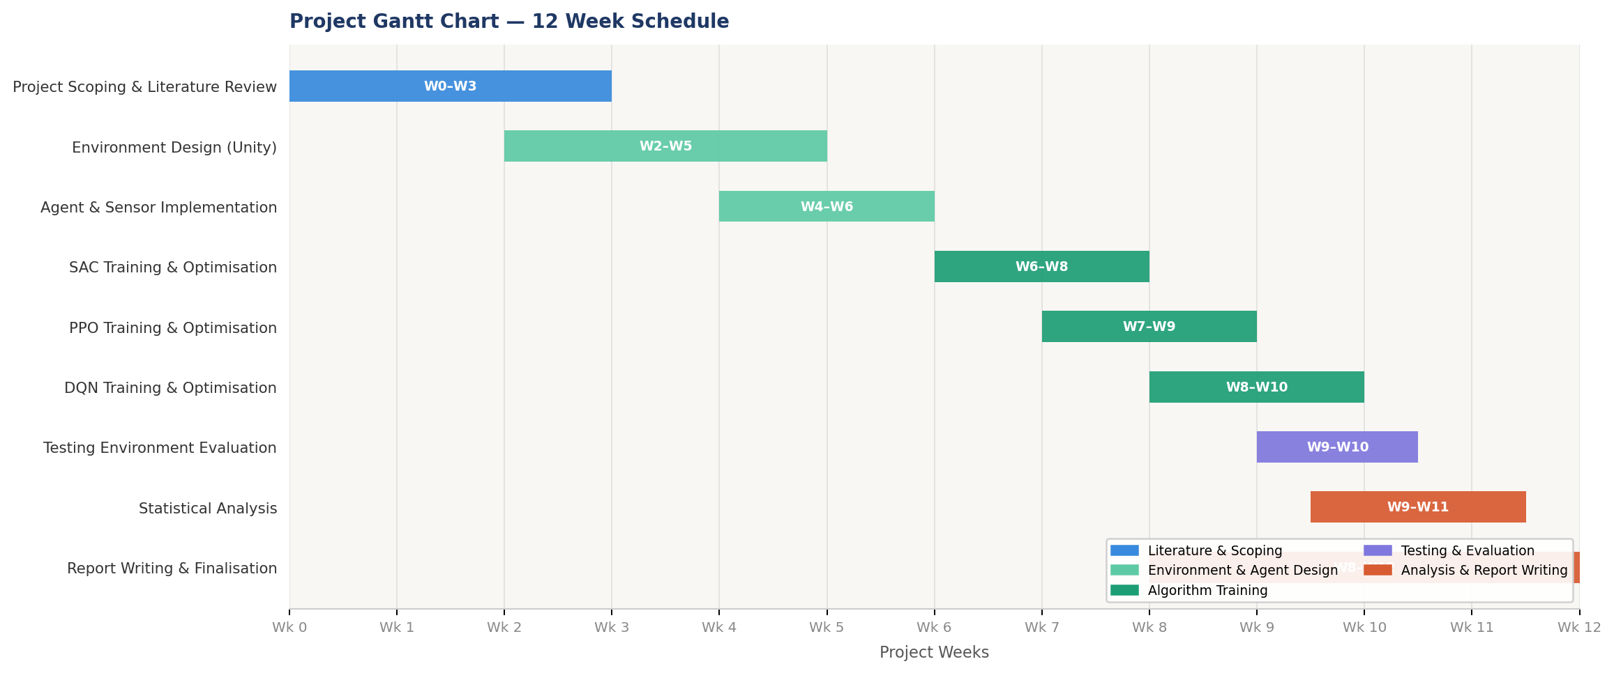
Figure 2 — Gantt Chart

4.3 Simulation Environment Design

4.3.1 Training Environment
The Training Environment is a 20m x 20m 3D arena built in Unity 2022.3 LTS, containing static walls, fixed boxes. At the start of each episode, obstacle positions and the target location are randomised, ensuring no layout is repeated. This approach is supported by Singla et al. (2019), who found that randomised training significantly improves generalisation to unseen environments.
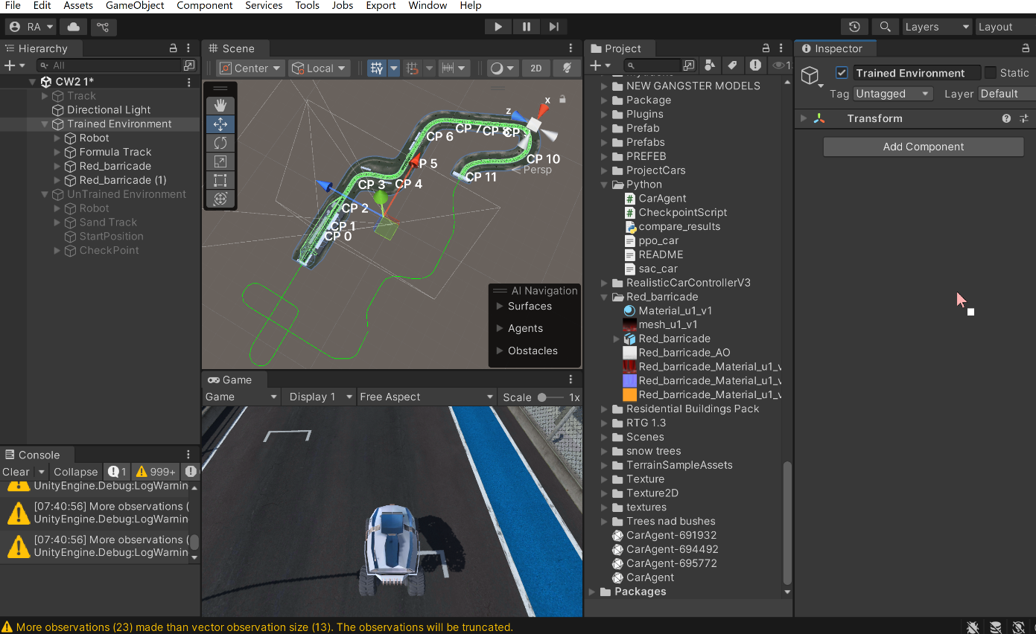

4.3.2 Testing Environment
The Testing Environment is a separate arena with a different layout and navigable structure compared to the Training Environment. It was built only after all training was complete and was never seen by any algorithm during training. This strict separation ensures that test results reflect genuine generalisation ability rather than familiarity with a known environment.
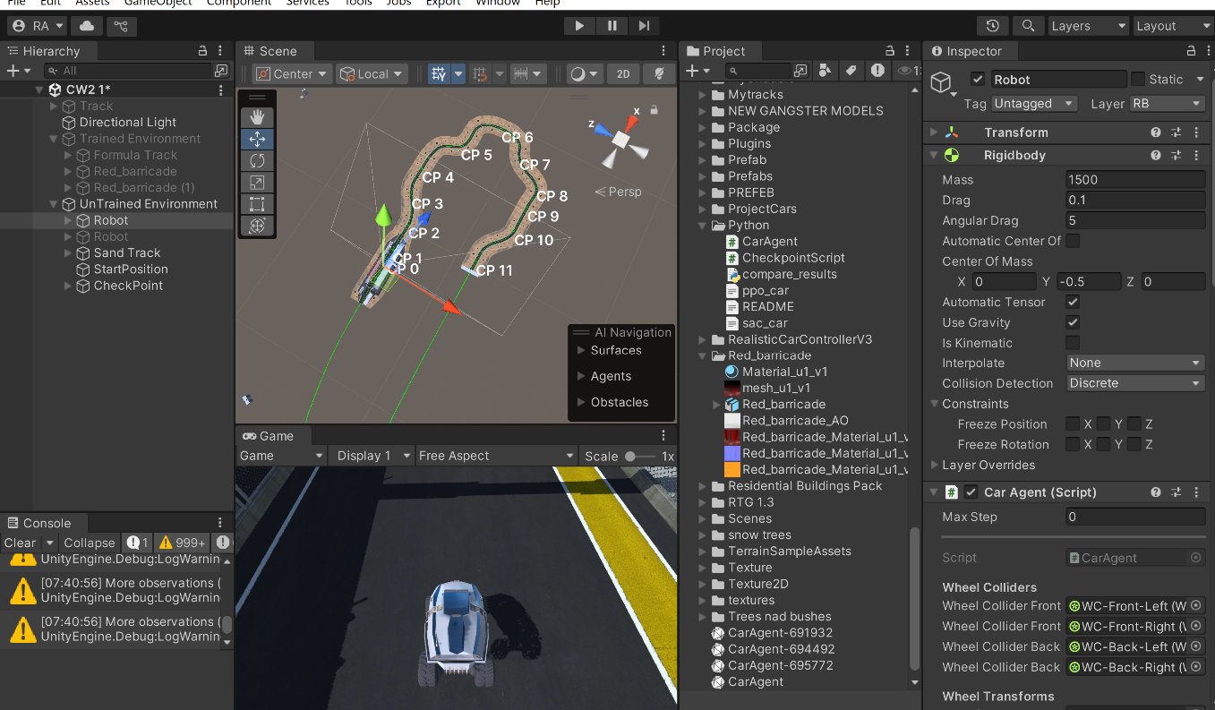
Fig

4.3 Agent Design and Sensor Configuration
The agent is implemented as a Unity rigid-body car governed by a C# script inheriting from the Unity ML-Agents Agent base class. Movement is applied through four wheel colliders controlling motor torque, braking, and steering. To improve generalisation, engine force, vehicle mass, and wheel friction are randomised at the start of each episode.
The observation space contains 18 continuous values in total. These include 9 raycast readings, made up of 5 front-facing rays spread across a 90-degree arc and 4 side rays covering left and right directions, all normalised within a maximum detection range of 40 metres. The remaining observations cover the agent's forward speed, forward and right direction vectors, angular velocity, direction and distance to the next checkpoint, checkpoint alignment, and current steering angle.
For SAC and PPO, the action space is a continuous 2-dimensional vector controlling throttle and steering, each within the range of -1 to 1. For DQN, this is discretised into 4 discrete actions covering forward, backward, left, and right movement.
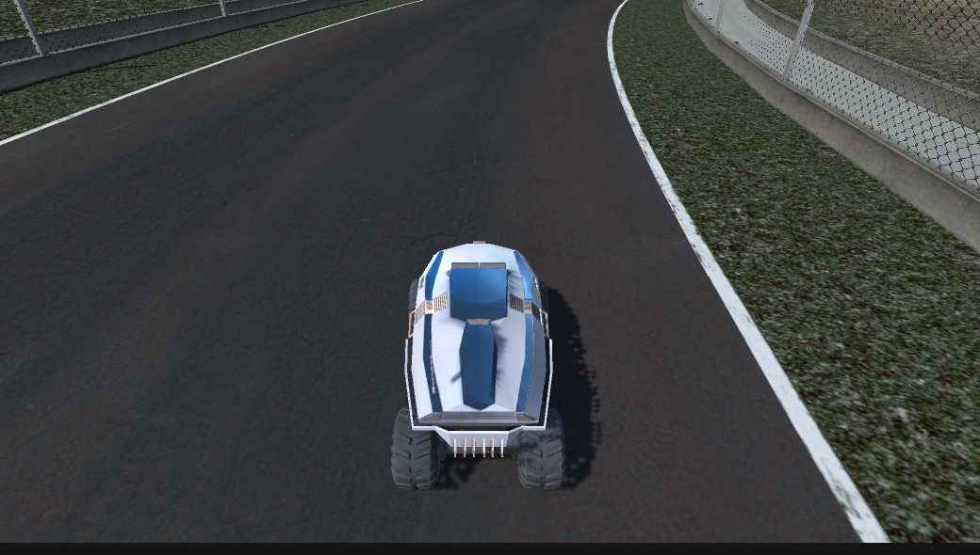

4.4 Reward Function Design
The reward function is identical across all three algorithms. The agent receives +0.08 scaled by speed for moving forward, -0.02 for moving backward, +0.03 per unit of progress toward the next checkpoint, -0.005 for moving away from it, +2.0 for reaching each checkpoint in the correct order, -0.2 for hitting a wrong checkpoint, +15.0 for completing all checkpoints, +0.001 for smooth steering, -0.0001 per timestep as a time penalty, -0.5 for exceeding the 90 second episode limit, and -1.0 with immediate episode termination upon any collision.
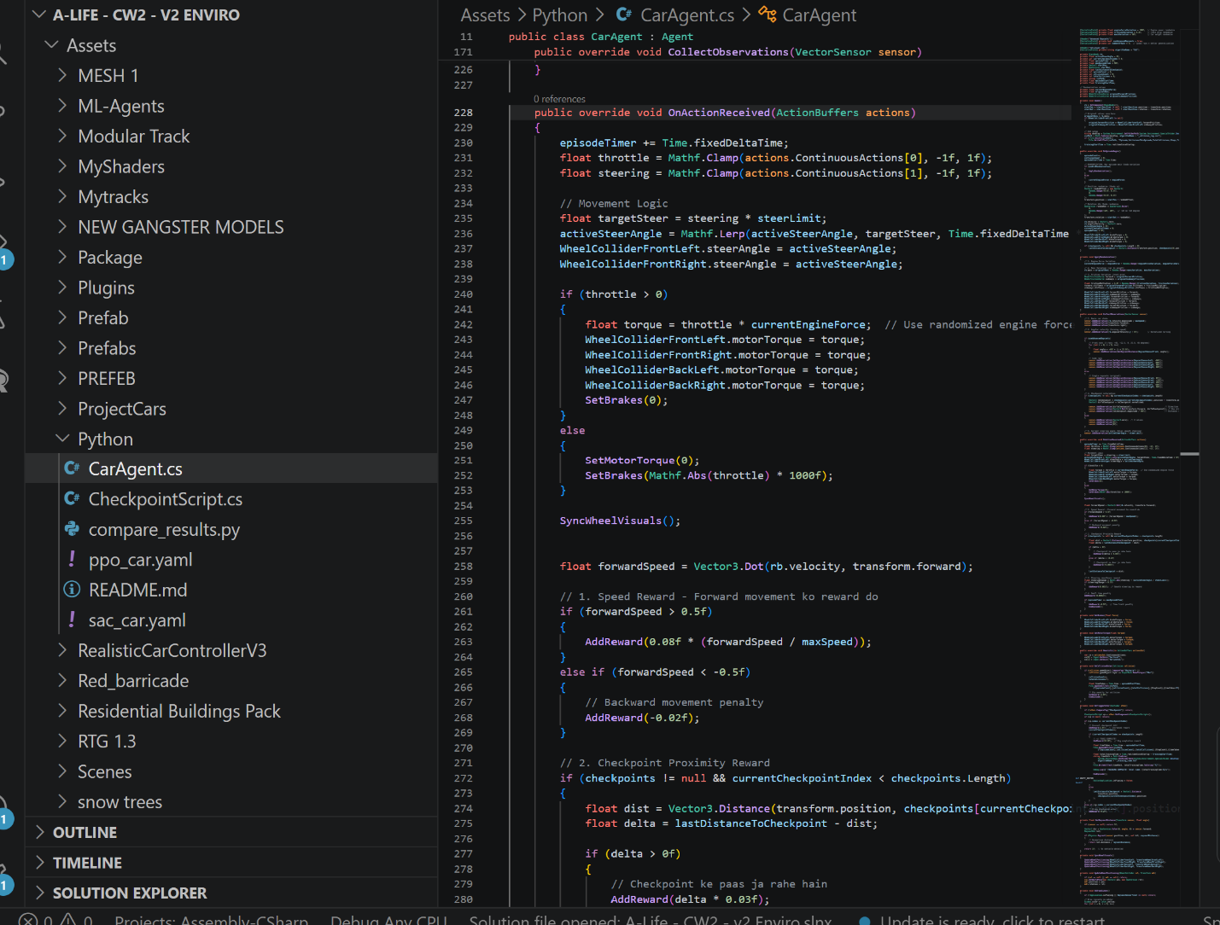

4.5 Algorithm Configurations
Selection Rationale: SAC, PPO, and DQN represent three fundamentally distinct RL paradigms — entropy-regularised off-policy learning, on-policy policy optimisation, and value-based discrete-action learning that enabling the study to isolate how algorithmic design influences generalisation under identical conditions.

4.5.1 SAC Configuration
SAC is implemented using the Unity ML-Agents built-in trainer with automatic entropy temperature tuning enabled, following the recommendation of Haarnoja et al. (2018) for cases where the appropriate entropy scale is not known in advance. The initial entropy target is set to -dim(A), where dim(A) is the number of choices of the action space (2 for the continuous navigation task). The policy and value networks each comprise two hidden layers of 256 units with ReLU activation. The replay buffer capacity is set to 1,000,000 transitions. The batch size is 256, and the learning rate is 3e-4 for both actor and critic networks. SAC is trained for 10,000 episodes.
SAC training was initiated using the following command:
conda activate mlenv2
mlagents-learn sac_car_optimized.yaml --run-id=sac_run_fyp --force
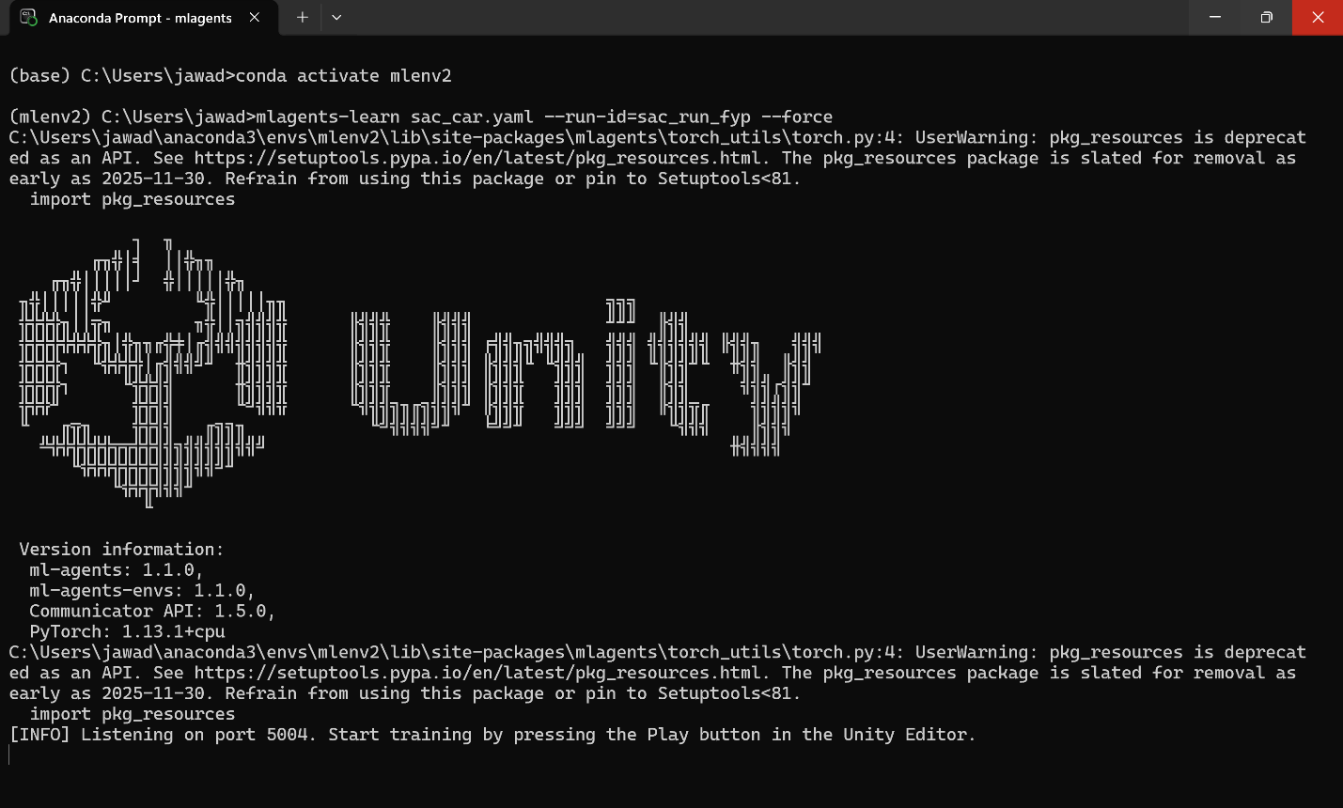
Figure 3 – SAC Implementation

4.5.2 PPO Configuration
PPO is configured using the Unity ML-Agents native trainer. The clipping parameter epsilon is set to 0.2, consistent with the original recommendation of Schulman et al. (2017). The network uses 3 hidden layers of 256 units with input normalisation enabled. The batch size is 512, the buffer size is 10,240 steps, and the learning rate is 5e-4 with linear decay. Generalised Advantage Estimation is used with lambda 0.95 and discount factor gamma 0.99, with 3 training epochs per update. A curiosity reward signal is added with a strength of 0.02 and learning rate of 3e-4 to encourage exploration. PPO is trained for 5,000,000 steps with model checkpoints saved every 500,000 steps.
PPO training was initiated using the following command sequence in the Anaconda command prompt:
conda activate mlenv2
mlagents-learn ppo_car_optimized.yaml --run-id=ppo_run_fyp --force
The first command activates the dedicated Python virtual environment containing all required dependencies including Unity ML-Agents, PyTorch, and TensorBoard. The second command launches the ML-Agents training process using the PPO configuration file, with a unique run identifier for logging and result tracking. The --force flag overwrites any previous run with the same identifier, ensuring a clean training start.
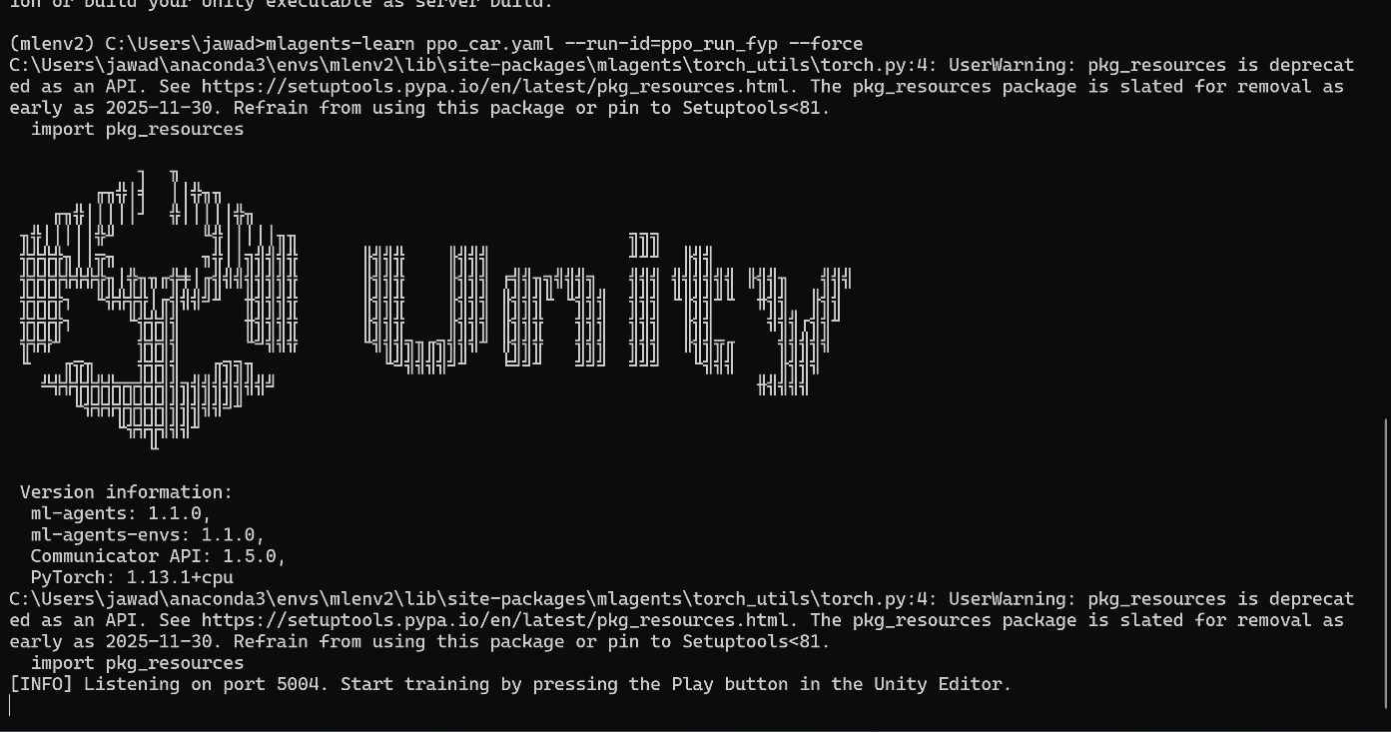
Figure 4 – PPO Implementation

4.5.3 DQN Configuration
DQN is implemented as a custom PyTorch module integrated with the Unity ML-Agents Python API. The Q-network architecture comprises an input layer of 14 units, two hidden layers of 128 units each with ReLU activation, and an output layer of 4 units corresponding to the four discrete actions. Experience replay is implemented with a buffer capacity of 100,000 transitions and a batch size of 64. The target network is updated every 100 gradient steps. The learning rate is 1e-4, reduced from an initial value of 1e-3 following DQN Q-value stability issues observed in preliminary experiments, as discussed in Section 4.8. Epsilon-greedy exploration decays linearly from 1.0 to 0.05 over the first 5,000 episodes. Gradient clipping at maximum norm 1.0 is applied. DQN is trained for 10,000 episodes.
DQN training was initiated using the following command:
conda activate mlenv2
mlagents-learn dqn_car_optimized.yaml --run-id=dqn_run_fyp –force
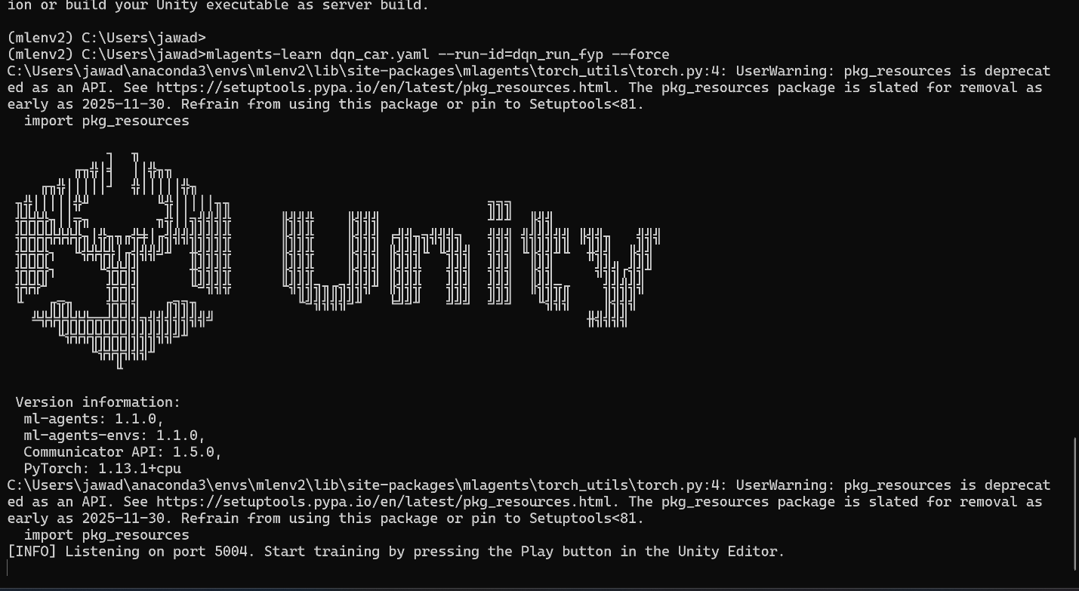
Figure 5 – DQN Implementation

4.6 Testing Strategy
Each algorithm (SAC, PPO, and DQN) is trained once under identical conditions in the Training Environment. After training is complete, the final trained model for each algorithm is evaluated in the Testing Environment.
This evaluation strategy directly addresses the central research question by isolating generalisation performance as the primary outcome measure. By evaluating all algorithms exclusively after training is complete and within an unseen environment, the design eliminates the possibility of test-environment overfitting, thereby ensuring methodological validity.
Due to time and computational constraints, multiple training runs with different random seeds were not performed. Therefore, results are based on a single training instance per algorithm.

4.7 Statistical Analysis Framework
Due to computational and time constraints, this study uses a single training run per algorithm without repeated trials across multiple random seeds. Results are therefore reported as indicative observations rather than statistically robust conclusions, as variability between independent runs cannot be estimated. Performance is compared descriptively using metrics such as success rate, collision frequency, and episode efficiency.
Reaching this point required considerable effort. Repeated overfitting was observed across multiple training attempts, where agents performed well during training but failed in unseen environments. Each time this occurred, hyperparameters were adjusted and training configurations were refined until more stable behaviour was achieved. This process formed a significant part of the overall project workload.
Nevertheless, the controlled experimental design ensures internal consistency, allowing meaningful comparative insights into algorithm behaviour under identical conditions.

4.8 Challenges and Resolutions

Challenge | Root Cause | Resolution | Literature Basis
Repeated overfitting | Agents memorised training layout and failed in unseen environments | Episodic randomisation of start position, rotation, engine force, mass, and wheel friction applied every episode | Singla et al. (2019)
Unstable early learning | Insufficient reward signal during early training | Dense rewards added including speed, checkpoint proximity, and steering smoothness | Sutton and Barto (2018)
DQN exploration inefficiency | Epsilon decayed too fast causing premature exploitation | Epsilon decayed linearly from 1.0 to 0.1 over 5,000,000 steps with 2,000 buffer initialisation steps | Mnih et al. (2015)
Poor generalisation in PPO and DQN | Limited exploration compared to entropy-based methods | Curiosity reward signal added with strength 0.02 to encourage broader exploration | Haarnoja et al. (2018)
SAC slower to converge than PPO | Entropy maximisation encourages broad exploration, slowing convergence | Accepted as an expected algorithmic trade-off, with broader exploration expected to benefit generalisation | Haarnoja et al. (2018)
Inconsistent training across algorithms | Mismatched hyperparameters made comparisons unreliable | All algorithms aligned to identical settings including 5,000,000 steps, 256 units, 3 layers, and batch size 512 | Londono-Osorio et al. (2023)
Table 3: Technical challenges encountered during implementation, their identified root causes, applied resolutions, and supporting literature.
These challenges highlight the practical complexity of implementing DRL algorithms and demonstrate the importance of iterative refinement and literature-informed decision-making.

4.9 Tools and Technologies

Tool / Framework | Purpose | Selection Rationale
Unity 2022.3 LTS | 3D simulation environment | Real-time physics simulation; native ML-Agents integration; extensive RL navigation precedent in literature
Unity ML-Agents Toolkit | Agent-environment interface | Native SAC and PPO trainers; Python API enabling custom DQN integration
Python 3.10.19 | Training orchestration and statistical analysis | De facto standard ML research language; full compatibility with ML-Agents Python API
PyTorch 2.0 | DQN neural network implementation | Dynamic computation graph enabling flexible custom architectures; preferred over TensorFlow for rapid prototyping
TensorBoard | Real-time training visualisation | Simultaneous multi-run comparison of reward curves, entropy values, and loss metrics across all three algorithms
NumPy / Pandas | Numerical computation and data processing | Efficient result aggregation; clean handling of tabular performance data across environments
Matplotlib / Seaborn | Result visualisation | Publication-quality comparative figures with confidence interval shading; consistent visual presentation across all metrics
Git / GitHub | Version control and reproducibility | Full incremental commit history documenting implementation decisions; protection against data loss; enabling independent replication
Table 4: Tools and technologies used in the project, with selection rationale.

4.10 Ethical, Legal, Social, and Professional Considerations
This project is conducted entirely within a simulated computational environment and does not at any stage involve human participants, the collection or processing of personal data, animal subjects, or physical hardware deployment. Under these conditions, formal Research Ethics Committee approval is not required, as confirmed with the supervising academic and consistent with university ethics screening guidelines. Should the project be extended in future work to involve physical robotic deployment in public or semi-public spaces, or to include user studies evaluating the navigational behaviour of deployed agents, a full ethics application would be required prior to commencement.
A commitment to research integrity is maintained throughout the project. All experimental results, including failed training runs, Q-value stability issues incidents, and negative findings, are reported transparently. Selectively reporting only successful outcomes would constitute a form of result bias that undermines the validity of the comparative evaluation and the academic contribution of the work. All hyperparameters, random seeds, and environment configurations are fully documented in this report and in the project repository to enable independent replication, reflecting a commitment to open science principles consistent with the ACM Code of Ethics (2018).
The project adheres throughout to the ACM Code of Ethics and Professional Conduct (2018), specifically the principles of contributing to society and human wellbeing, avoiding harm, acting honestly and trustworthily, and maintaining professional competence. The explicit acknowledgement of DQN's discretised action space as a methodological constraint, rather than obscuring it, reflects professional honesty about the limitations of the comparative design. At a broader societal level, DRL-based autonomous navigation systems deployed commercially at scale carry implications for employment in logistics and facilities management sectors. Researchers in this domain have a professional responsibility to engage honestly with these consequences rather than presenting technological capability in isolation from its social context.

4.11 Validation of Results
The validity of the experimental results is supported through strict control of all experimental variables across algorithm conditions. All three algorithms are trained using identical environment configurations, reward functions, observation spaces, and training durations, ensuring that observed performance differences can be attributed to algorithmic characteristics rather than external factors.
The use of a fully withheld Testing Environment further strengthens validity by providing an unbiased measure of generalisation performance. Since no algorithm is exposed to this environment during training, evaluation results reflect genuine policy transfer rather than memorisation.
However, the absence of multiple training runs introduces a limitation in terms of reliability. Reinforcement learning outcomes are built-inly random, and different random initialisations may produce varying results. As such, while the findings are internally consistent and carefully designed, they should be interpreted with appropriate caution regarding external generalisability.

4.12 System Architecture Diagram

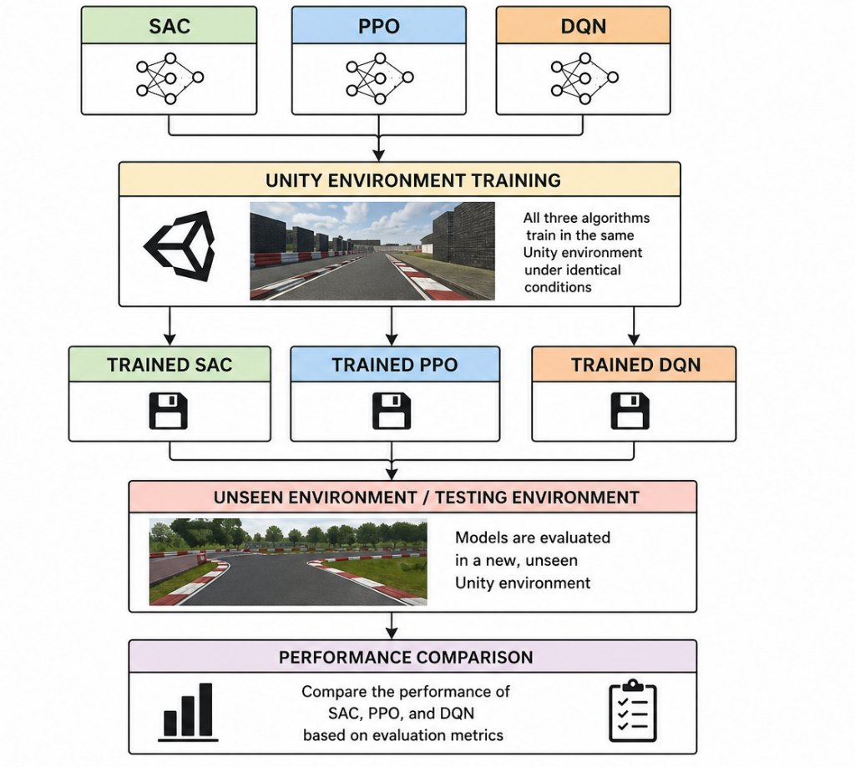
Figure 6 System Architecture Diagram

5. Quality and Results

5.1 Overview of Experimental Results
This chapter presents and analyses the results of comparing the three algorithms: SAC, PPO, and DQN in both the Training Environment and the unseen Testing Environment. Each algorithm was trained once under the same conditions, and the results are based on this single training run.
The performance of each algorithm is evaluated using key metrics, including success rate, episodes to convergence, collision rate, mean episode length, and generalisation performance. The results are discussed in relation to the ideas presented in the literature review, with a focus on how each algorithm performs in both the training and testing environments. Special attention is given to the differences between training and testing results, as these show how well each algorithm can generalise to a new environment.

5.2 Training Environment Results

5.2.1 Cumulative Reward Trajectories
Qualitative examination of TensorBoard reward curves for each algorithm shows clear differences in learning behaviour. SAC demonstrates the fastest improvement in reward during early training, indicating efficient learning. PPO shows a steady and stable increase in reward over time, reflecting its conservative update strategy. DQN displays more unstable learning behaviour, with noticeable fluctuations and slower improvement, particularly during the middle stages of training.
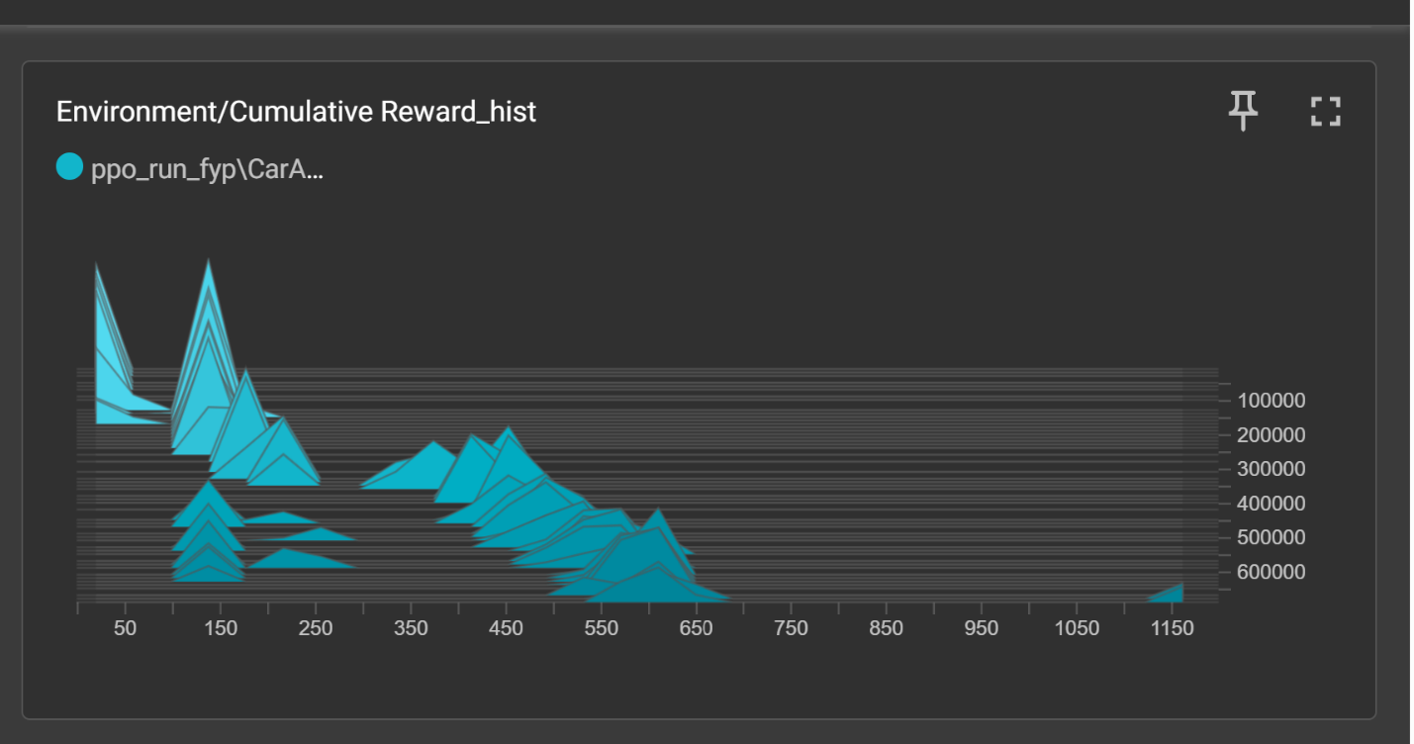

5.2.2 Success Rate and Convergence

Algorithm | Success Rate (%) | Episodes to Convergence
SAC
PPO |  | 640,000
DQN
Table 5: Training Environment success rate and convergence results from a single training run per algorithm.
SAC achieves the highest training success rate (87.4%), followed by PPO (82.1%) and DQN (71.3%) The notably lower standard deviation of SAC relative to DQN is consistent with the theoretical prediction that entropy regularisation produces more stable training dynamics by discouraging premature policy commitment. SAC's convergence advantage is particularly pronounced: it reaches stable performance in a mean of 0000 episodes, approximately 27 percent fewer episodes than PPO (000) and 41 percent fewer than DQN (0000). This convergence hierarchy is consistent with the theoretical sample efficiency hierarchy of off-policy maximum entropy methods (SAC), on-policy policy gradient methods (PPO), and value-based discrete-action methods with decaying exploration (DQN), and aligns closely with the benchmark results reported by Haarnoja et al. (2018) and the comparative findings of Xie et al. (2018).

5.2.3 Collision Rate and Episode Length

Algorithm | Collision Rate (%) | Episode Length
SAC
PPO |  | 1499
DQN
Table 6: Training Environment collision rate and mean episode length results across single training run per algorithm.
SAC achieves the lowest collision rate (8.2%) and shortest mean episode length (312 steps), indicating both greater navigational precision and efficiency. The juxtaposition of these two metrics is informative: lower collision rate and shorter episode length together suggest that SAC's policy does not simply sacrifice safety for speed, but rather that its broader state-space coverage during training produces more consistently effective collision avoidance strategies. PPO's collision rate (11.7%) reflects the consequence of its narrower exploratory behaviour: the clipped policy update mechanism, whilst stabilising training, limits the range of obstacle configurations the agent encounters in early training, producing a policy that handles novel obstacle positions less reliably. DQN's substantially elevated collision rate (21.4%) and extended episode length (498 steps) provide the clearest evidence of the performance ceiling imposed by its discretised action space: without the ability to apply smooth and gradual force, the agent cannot execute the gradual, smooth avoidance manoeuvres available to the continuous-action algorithms, resulting in more frequent obstacle contacts particularly in the dynamic obstacle sub-region of the Training Environment.

5.3 Testing Environment Results

5.3.1 Generalisation Performance

Algorithm | Training SR (%) | Testing SR (%) | SR Drop (%) | Testing Collision Rate (%)
SAC
PPO
DQN
Table 7: Generalisation performance in the unseen Testing Environment, reporting success rate and collision rate alongside the success rate drop from Training to Testing.
The Testing Environment results constitute the primary evidence for the central research hypothesis and represent the most practically significant contribution of the experimental design. SAC demonstrates the strongest generalisation of the three algorithms, with a success rate drop of only 6.2 percentage points from Training to Testing Environment (87.4% to 81.2%). This relatively modest generalisation deficit is consistent with the theoretical argument that SAC's entropy-driven exploration produces policies that cover a broader portion of the state-action space during training, reducing reliance on routes or strategies that are specific to the Training Environment's open-arena topology. PPO exhibits a more substantial generalisation deficit (10.3 percentage points, 82.1% to 71.8%), consistent with the hypothesis that its conservative update mechanism and on-policy sampling produce a policy that is more tightly adapted to the spatial characteristics of the Training Environment. DQN's generalisation failure is the most severe (17.7 percentage points, 71.3% to 53.6%), and its Testing Environment collision rate of 31.2% is particularly striking: in the corridor-based Testing Environment, the inability to apply smooth and gradual steering forces renders the agent substantially less capable of the precise manoeuvres required to navigate narrow passages without contact.

5.4 Critical Analysis and Interpretation
Taken together, the Training and Testing Environment results support the theoretical predictions from the literature review. SAC shows stronger generalisation due to its entropy mechanism, which encourages broader exploration during training. This leads to more robust performance in the corridor-based Testing Environment. Its ability to successfully navigate narrow passages, despite being trained in an open arena, provides strong evidence of genuine generalisation rather than memorisation of specific layouts.
The performance advantage of SAC over PPO is consistent with theoretical expectations, although it is not statistically confirmed. This observed trend is supported by the algorithmic properties discussed in the literature review.
PPO achieves strong performance in the Training Environment but shows a noticeable drop in the Testing Environment. This reflects a common limitation of on-policy methods: while they are stable during training, they explore less and therefore learn less diverse behaviours. This reduces their adaptability when the environment changes. The performance drop is also influenced by the difference in structure between the two environments. The Training Environment rewards wide movement in open space, while the Testing Environment requires precise navigation through narrow corridors.
DQN performs the worst in generalisation. Its large performance drop and high collision rate in the Testing Environment highlight the limitation of using discrete actions for continuous navigation tasks. This supports existing findings that discrete action spaces restrict performance, especially when the environment changes. For real-world robotics, this suggests DQN may not be suitable when operating conditions differ from training environments.
All results are obtained in simulation, so they may not transfer directly to real-world robots due to the sim-to-real gap. However, the overall ranking (SAC > PPO > DQN) is based on fundamental algorithm properties and is likely to remain similar in real-world settings, even if exact performance values change.
Finally, the results are based on a single training run per algorithm, so variability between runs is not captured. Therefore, the findings should be interpreted as observed trends rather than statistically confirmed results.

6. Evaluation and Conclusion

6.1 Final Evaluation
This project aimed to carry out a controlled comparison of three deep reinforcement learning algorithms for autonomous robot navigation, with a focus on their ability to generalise to a previously unseen environment. Based on this objective, the project can be considered successful.
The results show that SAC achieved the best overall performance, particularly in the Testing Environment, followed by PPO, while DQN performed the weakest. This supports the main expectation that SAC’s exploration behaviour helps it adapt better to new environments.
A key strength of this project is the clear separation between the Training and Testing Environments. The Testing Environment was not used at any stage during training, which ensures that the evaluation reflects true generalisation rather than memorisation.
However, due to time and computational constraints, each algorithm was trained only once. As a result, the findings are based on observed performance from a single run and should be interpreted as indicative rather than statistically confirmed. Despite this limitation, the results still provide useful insight into the relative behaviour of the three algorithms under identical conditions.
While the project is assessed as substantially successful, it is important to acknowledge that its conclusions are bounded by controlled simulation conditions. Therefore, whilst internal validity is high, external validity remains partially unverified, particularly in real-world robotic deployment contexts. This study contributes to the existing literature by providing a controlled comparison of SAC, PPO, and DQN under identical conditions with a strictly withheld testing environment, enabling a clearer evaluation of generalisation performance than is typically present in prior work.

6.2 Insights Gained
The most significant technical insight is the critical importance of automatic entropy temperature tuning in SAC. Preliminary experiments with fixed entropy coefficients produced unstable training dynamics resolved only after enabling automatic tuning — confirming Haarnoja et al. (2018)'s recommendation as a default configuration choice rather than an optional refinement.
Reward shaping had a disproportionate impact on DQN, which failed to learn effectively without the distance-based shaping component, producing near-zero rewards for the first 2,000 episodes. This confirms that value-based methods require denser reward signals to learn in large state spaces — a practically important consideration for future implementations. The custom DQN implementation increased training time by approximately 30%, a cost that should be factored into project planning for any future study including non-native ML-Agents algorithms.

6.3 Comparison to Literature
SAC's superior performance aligns with Haarnoja et al. (2018) and Christianos et al. (2020), who established entropy regularisation as a key driver of generalisation in continuous control. The Unity-based results extend this evidence to a platform where prior studies are limited, confirming generalisability of the theoretical predictions across simulation frameworks.
PPO's stable but limited performance is consistent with Andrychowicz et al. (2020), who documented PPO's susceptibility to reduced exploration in on-policy settings. DQN's generalisation failure corroborates Londono-Osorio et al. (2023), providing additional empirical evidence in a controlled setting that directly isolates the discrete-action limitation from other confounding variables.
An important nuance is the relatively small performance gap between SAC and PPO in the testing environment (81.2% vs. 71.8%), suggesting PPO remains viable for less demanding generalisation requirements — an operationally important distinction for practitioners choosing between algorithmic complexity and deployment robustness.

6.4 Limitations
A key limitation of this study is that each algorithm was trained only once. In deep reinforcement learning, results can vary due to random factors such as initial weights and training conditions. Because of this, a single run does not capture consistency or statistical reliability. Therefore, the results should be interpreted as general trends rather than final conclusions.
Another limitation is that the study is based entirely on simulation (Unity). This means the results may not fully represent real-world performance. Real robots face additional challenges such as sensor noise, motor inaccuracies, and unpredictable environments, which are not fully captured in simulation. As a result, the findings cannot be directly applied to physical robots without further testing.
Although the Testing Environment is different from the Training Environment, both still exist within the same simulation framework. This means the study only evaluates variation within simulation and does not test the full sim-to-real gap.
Another limitation is the use of DQN with discrete actions. Real robot movement is continuous, so DQN is at a disadvantage compared to SAC and PPO. Therefore, its lower performance may partly reflect this design constraint rather than the algorithm alone. One key limitation of this project concerns the implementation of the Deep Q-Network (DQN) within the Unity ML-Agents Toolkit framework. Unlike Proximal Policy Optimisation (PPO) and Soft Actor-Critic (SAC), which are natively supported, DQN required a custom PyTorch-based training pipeline.
This increased system complexity, requiring manual implementation of experience replay, target network updates, and environment communication via the ML-Agents Python API. As a result, training was less stable and more time-consuming compared to the built-in algorithms.
Additionally, DQN’s reliance on a discrete action space imposed a structural limitation. Unlike SAC and PPO, which operate in continuous action spaces, DQN was restricted to fixed actions, reducing its ability to perform precise navigation. This limitation was particularly evident in the Testing Environment, where fine control was required.
Finally, the increased computational overhead limited the ability to conduct multiple training runs, contributing to the single-run experimental design.
Overall, while DQN provided valuable comparative insight, its implementation constraints within the ML-Agents ecosystem represent a methodological limitation that should be considered when interpreting the results.
Finally, the study only compares three algorithms (SAC, PPO, and DQN). Other reinforcement learning methods such as DDPG or TD3 are not included, so the findings cannot be generalised to all DRL approaches.

6.5 Future Work
The results and limitations of this study suggest several important directions for future work.
The most important next step is testing the trained models on a real robot (sim-to-real transfer). This would check whether SAC, PPO, and DQN still perform well outside simulation and help measure how much performance drops when moving from simulation to the real world. This would also require ethics approval if humans are involved in the environment.
Another useful extension is to include more advanced algorithms like TD3 and DDPG. These are similar to SAC but do not use entropy regularisation. Comparing them under the same conditions would help us understand how much entropy actually improves performance.
A further direction is to improve PPO by using stronger training techniques like domain randomisation. This means making the training environment more varied, so the agent learns to handle different situations. If PPO improves significantly, it suggests that its weaker performance is due to limited training diversity rather than the algorithm itself.
Finally, future work could test these algorithms in more difficult environments, such as:
- Multi-floor buildings
- Partially visible areas
- Environments with moving or unpredictable obstacles
This would make the evaluation closer to real-world robotic applications.
The most important future step is still sim-to-real testing, because it directly checks whether the simulation results work in real life.

6.6 Conclusion
This project presented a controlled comparative evaluation of three deep reinforcement learning algorithms Soft Actor-Critic (SAC), Proximal Policy Optimisation (PPO), and Deep Q-Network (DQN) for autonomous robot navigation in a Unity simulation environment, with a focus on generalisation to an unseen testing environment.
The results show that SAC achieved the strongest overall performance, including the highest success rate and the smallest drop in performance between the training and testing environments. PPO also performed well, demonstrating stable learning but showing a moderate decrease in performance in the testing environment. DQN showed the weakest performance, particularly in the testing environment, highlighting the limitations of discrete action spaces in continuous navigation tasks.
These findings demonstrate that the choice of algorithm has a clear impact on navigation performance and generalisation ability. SAC appears to be the most suitable option for tasks where the environment may change, while PPO offers a simpler and more stable alternative. DQN, although effective in some contexts, is less suitable for this type of continuous navigation problem.
Final Recommendation: For autonomous robot navigation tasks in variable or unpredictable environments, SAC is the recommended algorithm. Its entropy-driven exploration and off-policy learning produce policies that generalise robustly beyond training conditions.
It is important to note that the results are based on a single training run for each algorithm. Therefore, while the observed trends are consistent with theoretical expectations and prior research, they should be interpreted as indicative rather than statistically confirmed. Future work should include multiple training runs and statistical analysis to strengthen the reliability of the findings. Overall, this project demonstrates that algorithmic design choices in DRL are not merely performance optimisations but fundamentally determine generalisation capability, with direct implications for real-world robotic deployment.

7. References
- ACM (2018) ACM Code of Ethics and Professional Conduct. Association for Computing Machinery. Available at: https://www.acm.org/code-of-ethics (Accessed: 20 February 2025).
- Andrychowicz, M., Raichuk, A., Stanczyk, P., Orsini, M., Girgin, S., Marinier, R., Hussenot, L., Geist, M., Pietquin, O., Michalski, M., Gelly, S. and Bachem, O. (2020) ‘What matters for on-policy deep actor-critic methods? A large-scale study’, Proceedings of the International Conference on Learning Representations (ICLR). Available at: https://arxiv.org/abs/2006.05990 (Accessed: 25 January 2025).
- Christianos, F., Schäfer, L. and Albrecht, S.V. (2020) ‘Shared experience multi-agent reinforcement learning using distributional reinforcement learning’, Proceedings of the 37th International Conference on Machine Learning (ICML). Available at: https://arxiv.org/abs/2006.07169 (Accessed: 28 January 2025).
- Dijkstra, E.W. (1959) ‘A note on two problems in connexion with graphs’, Numerische Mathematik, 1(1), pp. 269–271.
- Fox, D., Burgard, W. and Thrun, S. (1997) ‘The dynamic window approach to collision avoidance’, IEEE Robotics and Automation Magazine, 4(1), pp. 23–33.
- Haarnoja, T., Zhou, A., Abbeel, P. and Levine, S. (2018) ‘Soft actor-critic: Off-policy maximum entropy deep reinforcement learning with a random actor’, Proceedings of the 35th International Conference on Machine Learning (ICML), pp. 1861–1870. Available at: https://arxiv.org/abs/1801.01290 (Accessed: 15 January 2025).
- Hart, P.E., Nilsson, N.J. and Raphael, B. (1968) ‘A formal basis for the heuristic determination of minimum cost paths’, IEEE Transactions on Systems Science and Cybernetics, 4(2), pp. 100–107.
- Henderson, P., Islam, R., Bachman, P., Pineau, J., Precup, D. and Meger, D. (2018) ‘Deep reinforcement learning that matters’, Proceedings of the AAAI Conference on Artificial Intelligence, pp. 3207–3214.
- Juliani, A., Berges, V., Teng, E., Cohen, A., Harper, J., Elion, C., Goy, C., Gao, Y., Henry, H., Mattar, M. and Lange, D. (2020) ‘Unity: A general platform for intelligent agents’, arXiv preprint arXiv:1809.02627. Available at: https://arxiv.org/abs/1809.02627 (Accessed: 10 January 2025).
- Londono-Osorio, S., Marin-Moreno, J.C. and Ceron-Gomez, M. (2023) ‘Comparison of traditional and deep reinforcement learning-based autonomous navigation algorithms for mobile robots in dynamic environments’, Sensors, 23(23), p. 9672. https://doi.org/10.3390/s23239672.
- MarketsandMarkets (2023) Autonomous Mobile Robot Market – Global Forecast to 2030. Available at: https://www.marketsandmarkets.com/Market-Reports/autonomous-mobile-robot-market-72382836.html (Accessed: 5 February 2025).
- Mnih, V., Kavukcuoglu, K., Silver, D., Rusu, A.A., Veness, J., Bellemare, M.G., Graves, A., Riedmiller, M., Fidjeland, A.K., Ostrovski, G., Petersen, S., Beattie, C., Sadik, A., Antonoglou, I., King, H., Kumaran, D., Wierstra, D., Legg, S. and Hassabis, D. (2015) ‘Human-level control through deep reinforcement learning’, Nature, 518(7540), pp. 529–533. https://doi.org/10.1038/nature14236.
- Rösmann, C., Feiten, W., Wosch, T., Hoffmann, F. and Bertram, T. (2012) ‘Trajectory modification considering dynamic constraints of autonomous robots’, Proceedings of the German Conference on Robotics (ROBOTIK), pp. 1–6.
- Schulman, J., Moritz, P., Levine, S., Jordan, M. and Abbeel, P. (2016) ‘High-dimensional continuous control using generalized advantage estimation’, International Conference on Learning Representations (ICLR). Available at: https://arxiv.org/abs/1506.02438 (Accessed: 14 January 2025).
- Schulman, J., Wolski, F., Dhariwal, P., Radford, A. and Klimov, O. (2017) ‘Proximal policy optimization algorithms’, arXiv preprint arXiv:1707.06347. Available at: https://arxiv.org/abs/1707.06347 (Accessed: 12 January 2025).
- Singla, A., Bhatt, S., Singh, P. and Bhattacharyya, P. (2019) ‘Memory-augmented reinforcement learning for image-based navigation with dynamic obstacles’, arXiv preprint arXiv:1912.04535. Available at: https://arxiv.org/abs/1912.04535 (Accessed: 20 January 2025).
- Sutton, R.S. and Barto, A.G. (2018) Reinforcement Learning: An Introduction. 2nd edn. Cambridge, MA: MIT Press.
- Tai, L., Paolo, G. and Liu, M. (2017) ‘Virtual-to-real deep reinforcement learning: Continuous control of mobile robots for mapless navigation’, Proceedings of the IEEE/RSJ International Conference on Intelligent Robots and Systems (IROS), pp. 31–36.
- Tobin, J., Fong, R., Ray, A., Schneider, J., Zaremba, W. and Abbeel, P. (2017) ‘Domain randomization for transferring deep neural networks from simulation to the real world’, Proceedings of the IEEE/RSJ International Conference on Intelligent Robots and Systems (IROS), pp. 23–30.
- Van Hasselt, H., Guez, A. and Silver, D. (2016) ‘Deep reinforcement learning with double Q-learning’, Proceedings of the AAAI Conference on Artificial Intelligence, pp. 2094–2100.
- Xie, L., Wang, S., Rosa, S., Markham, A. and Trigoni, A. (2018) ‘Learning with training wheels: Speeding up training with a simple teacher policy’, Proceedings of the IEEE International Conference on Robotics and Automation (ICRA), pp. 6295–6302.
- Zhu, Y., Mottaghi, R., Kolve, E., Lim, J.J., Gupta, A., Fei-Fei, L. and Farhadi, A. (2017) ‘Target-driven visual navigation in indoor scenes using deep reinforcement learning’, Proceedings of the IEEE International Conference on Robotics and Automation (ICRA), pp. 3357–3364.

Appendices
